DAY -5

ZECPATH AI

Project Prepared By Suhail TP

Resume Parsing Engine

1.Objective

Implement a Resume Parsing Engine that extracts text from candidate resumes (PDF or DOCX format) and prepares the data for AI-based recruitment analysis.

2. System Overview
The resume parser reads resumes from a data folder, extracts text using Python libraries, cleans the text, and sends the processed data to the AI screening pipeline.

3. Project Structure
ZECAPATH_AI
│
├── data
│ └── sample_resumes
│ └── resume1.pdf
│
├── parsers
│ └── resume_parser.py
│
├── schemas
│ ├── job_schema.json
│ └── resume_schema.json
│
├── tests
│ └── test_parser.py
│
├── main.py
├── README.md

4. Environment Setup

Step 1 – Activate Virtual Environment
source zecpath_env/bin/activate
Step 2 – Install Required Libraries
pip install pdfplumber python-docx nltk pandas pytest
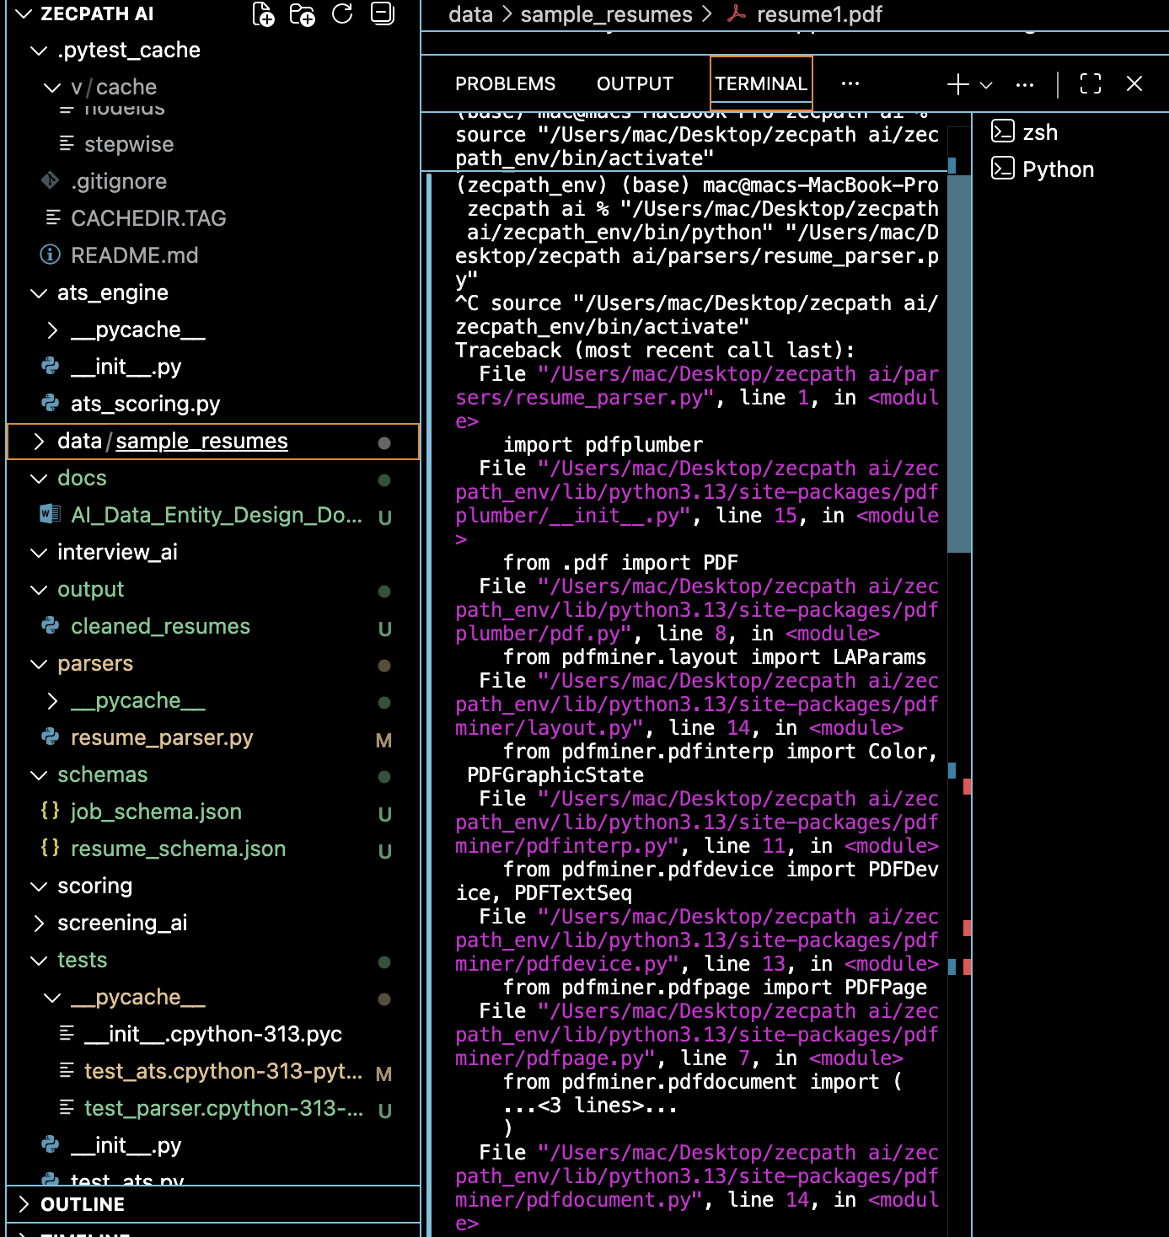

5. Resume Text Extraction

The parser extracts text from both PDF and DOCX resumes.
PDF Extraction Libraries: pdfplumber
DOCX Extraction Libraries: python-docx
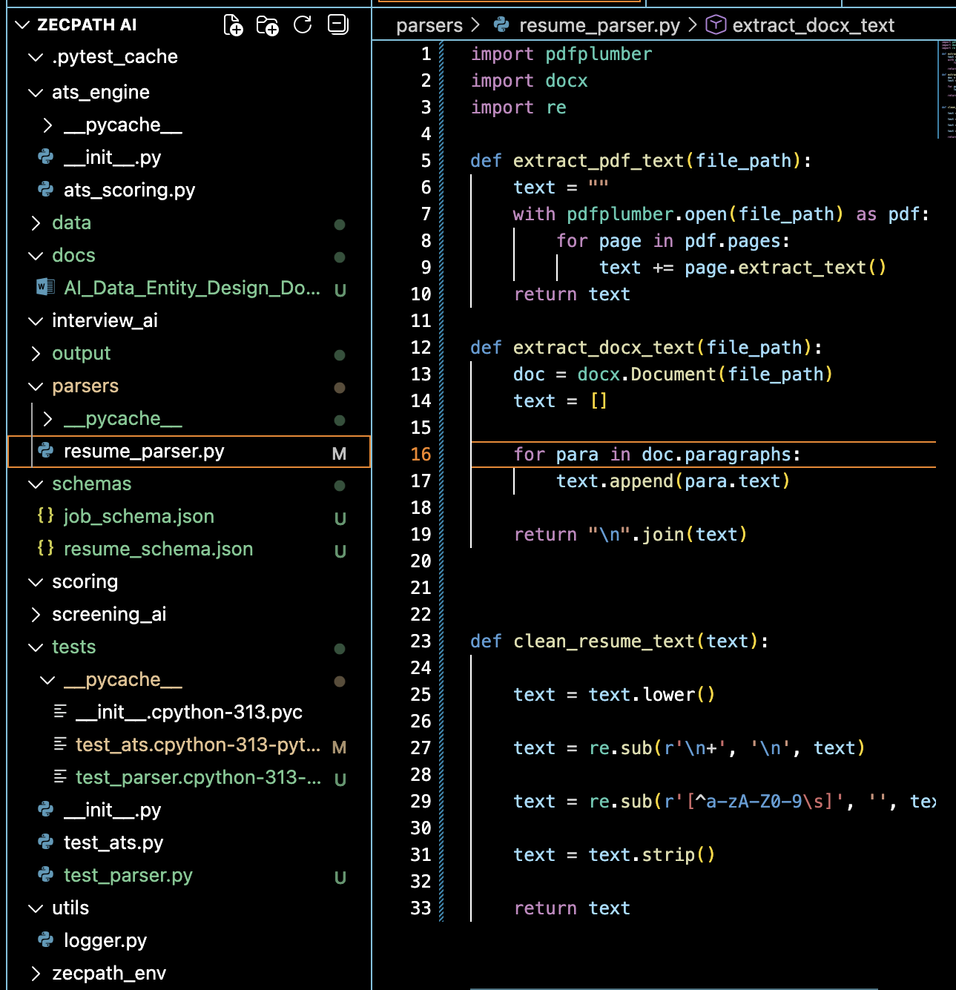

6. Store cleaned resumes
Create folder:
Output/ cleaned resumes
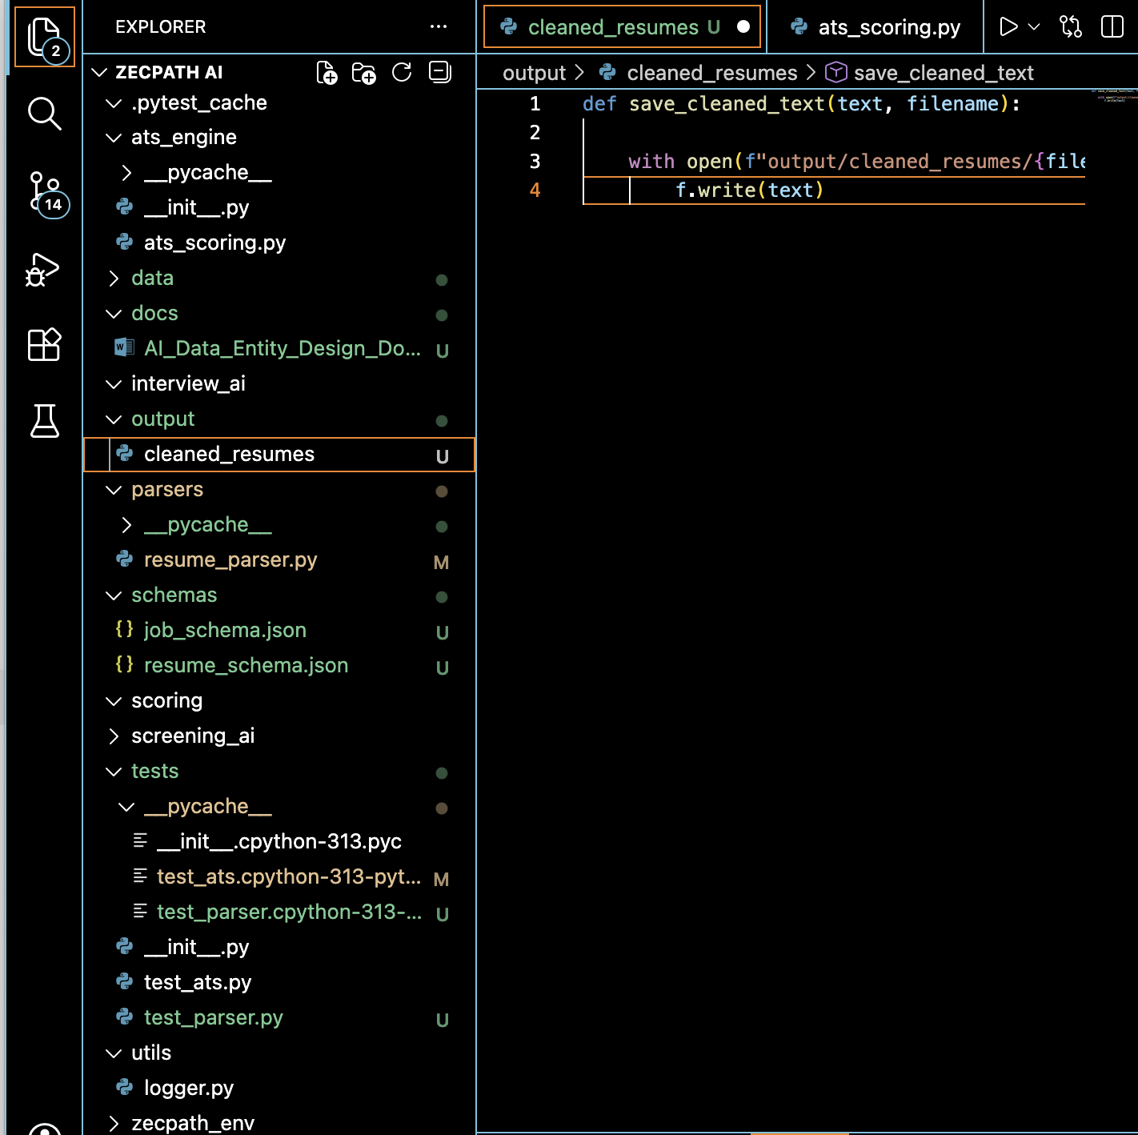

7. Core Functions
extract_pdf_text(file_path)
Reads PDF resume and extracts text page by page.
extract_docx_text(file_path)
Reads DOCX resume and extracts paragraph text.
clean_resume_text(text)
Removes special characters, extra spaces and converts text to lowercase.
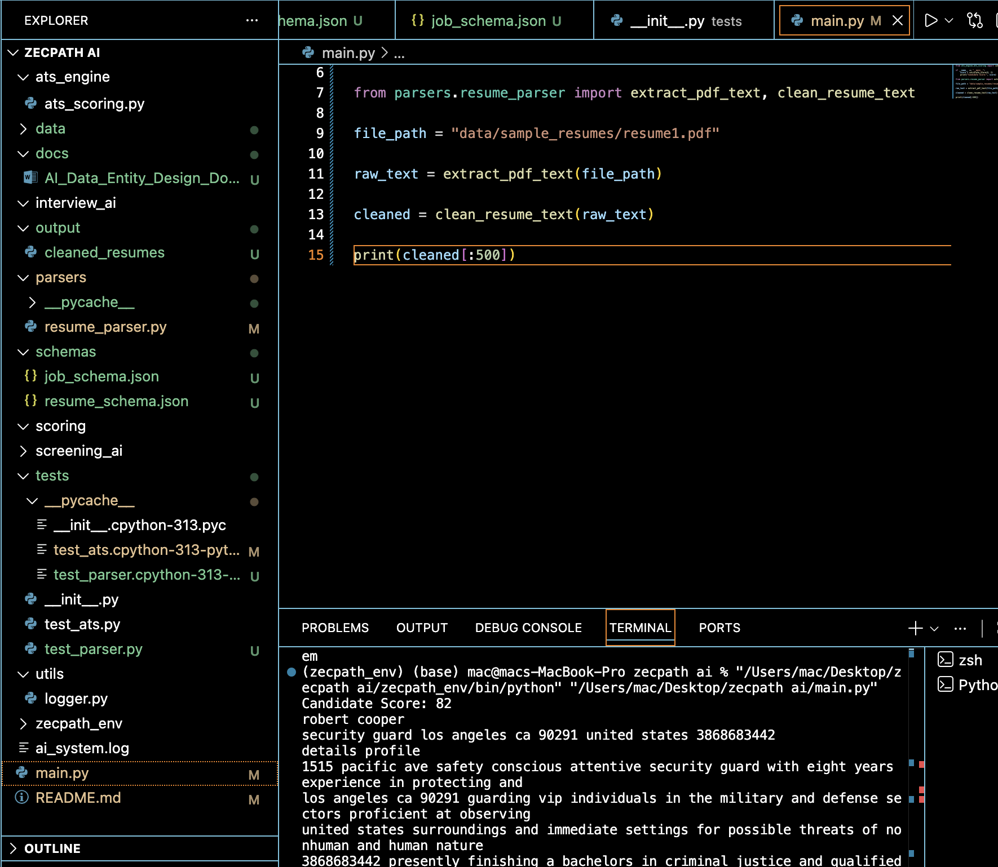

8. Testing the Parser
Run the automated test using:
pytest
The test checks whether resume text is successfully extracted from the sample resume file.

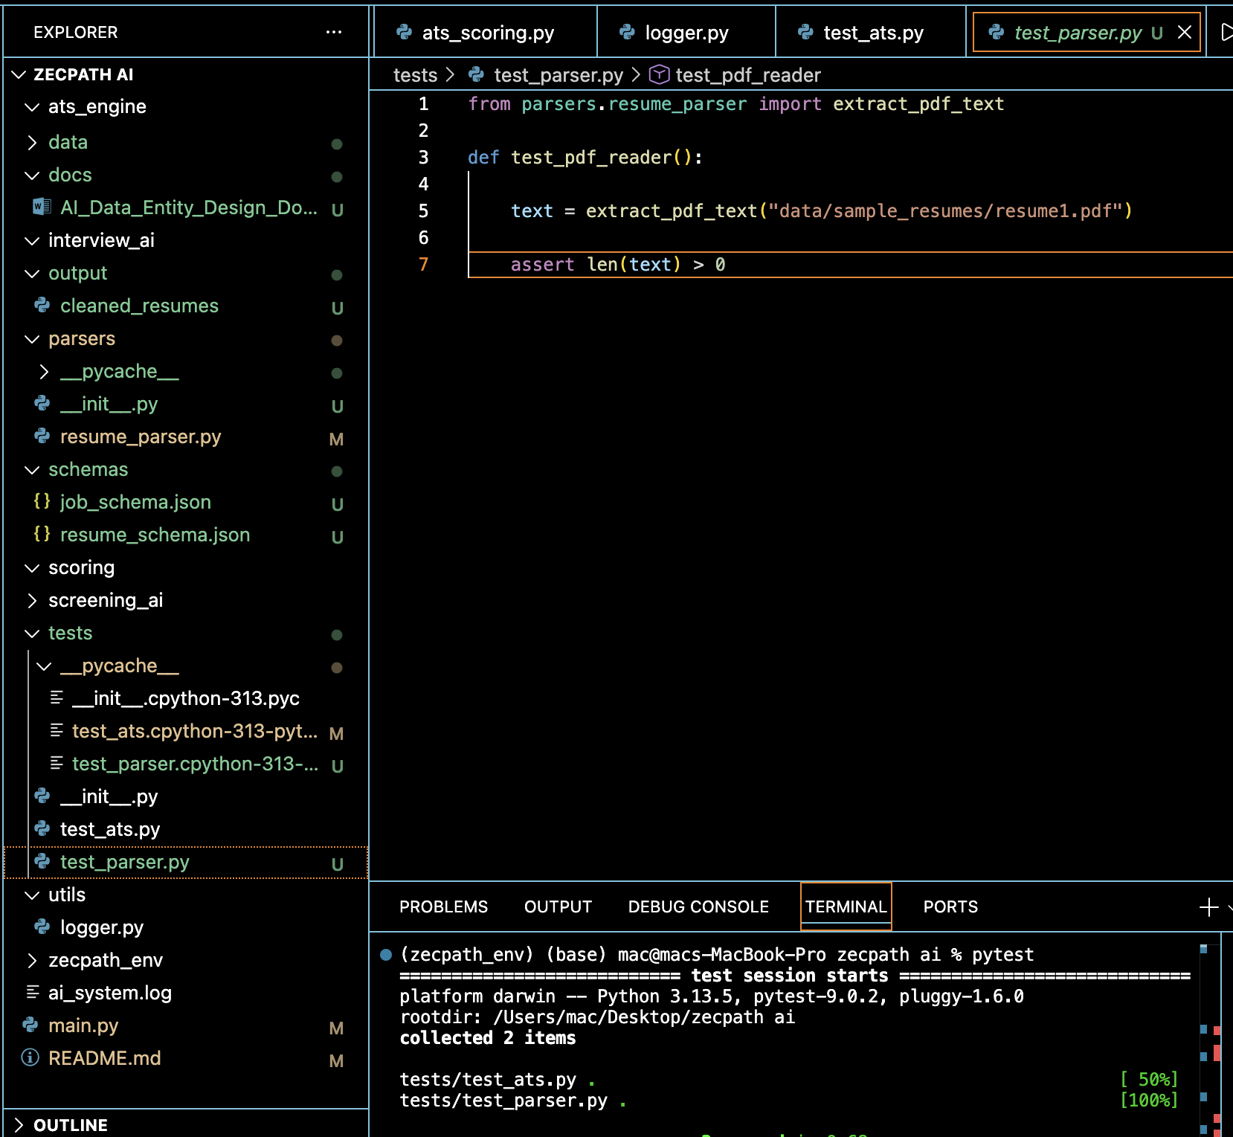

9. Output

The system extracts raw resume text which will be used in later modules such as skill extraction, candidate scoring, and AI screening.

10. Result

Resume parsing module successfully extracts text from resumes and prepares the data for AI processing.

11. Conclusion

The Day 5 implementation establishes the foundation of the AI recruitment pipeline by converting unstructured resume documents into machine-readable text.

